**UCS304**

**SOFTWARE REQUIREMENT SPECIFICATION**

**AUTOMATION OF TIME-TABLE**

**SUBMITTED TO:**

Mr. Shatrughan Modi

**SUBMITTED BY :**

Ashish Kumar Pandey (101503051)

Danish Sawa (101503069)

Devesh Kumar Singh (101503071)

Ekamjit Singh (101503075)

**TABLE OF CONTENT**

1. INTRODUCTION 4

1.1 PURPOSE

1.2 SCOPE

1.3 OVERVIEW

1.4 DEFINITION

1.5 REFERENCES

1.6 REQUIREMENTS

2. OVERALL DESCRIPTION 5

2.1 CONSTRAINTS

2.2 SOFTWARE FUNCTIONS

2.3 TARGET USERS

2.4ASSUMPTIONS AND DEPENDENCIES

3. SPECIFIC REQUIREMENTS 7

3.1 USER INTERFACE

3.2 COMMUNICATION INTERFACE

3.3 SOFTWARE, SYSTEM AND ATTRIBUTES

4. WORKFLOW 8

4.1 REQUIREMENT ANALYSIS

4.2 ANALYSIS OF TABLE AND CONSTRAINTS

4.3 FINALIZING THE TABLES

5. REFERENCES 17

**1.Introduction**

**1.1 Purpose:**

This report intends to give the expected do-about of the Lab project for SE subject.

Basically we intend to automate the time table creation of any group/department/institute.

Our group intends to replace the age-old manual method of time table creation adopted in most universities.

**1.2 Scope:**

We will use java/python to build an application that generates the time table using the concepts of Genetic Algorithm.

The manual databases are collected from several departments of THAPAR UNIVERSITY via various time-table co-ordinaters of that particular departments.

Keeping in consideration all the data acquired our program will generate a time-table which will aim to satisfy the requirements.

**1.3 Overview:**

We target to reduce the complexity and decrease the man hours wasted on a simple thing as time table creation, leaving all the complexity to the machine called computer.

Manual database and procedures will be succeeded by programs.

**1.5 References:**

IEEE SRS format.

Manual databases collected from Departments.

various photographs taken from manual databases.

**1.6 Requirements:**

GUI(Graphical User Interface)

backend language (Java / Python)

**2. Overall Description:**

**2.1 Constraints:**

a). Total Workload of any teacher. That is the maximum number of hours a teacher can teach during the whole weak.

b). Total number of students a room can fit.

c). Total number of rooms available at any given hour.

d). Other specified constraints of individual teachers. e.g. no two consecutive lectures.

e). Tutorials and laboratory type and capacity.

**2.2 Software Functions:**

a). A graphical interface which helps the teachers and other concerned faculty members to input their respective data.

b). A program which calculates the room availability.

c). A program which assigns the rooms for lectures, tuts and labs.

d). A full-fledged database of all the tables of individual departments and teachers.

f). The final program generating the time table.

**2.3 Target Users:**

a). All the TIME TABLE COMMITTEE members involved in generation of the time table. Department wise and the Final committee.

b). "All" the teachers of THAPAR UNIVERSITY.

c). "All" the students of THAPAR UNIVERSITY.

d). All the clerical people involved in time table creation.

e). The exam co-ordinaters and seating plan generators.

**2.4 Assumptions and dependencies:**

a). Room availabilities and strength.

b). No backlog students take up the course.

c). No Teacher leaves/joins the college, or changes the department.

d). No room goes for maintenance or goes out-of-order in middle of any semester.

e). No teacher increases or decreases the work load assigned in the initialisation of the semester.

f). The data provided is correct.

g). The strength of any group doesn't increase or decrease during the whole semester.

i). No new rooms/labs are made functional during the semester.

**3. Specific Requirements:**

**3.1 User Interfaces:**

a). Graphical User Interface for teachers etc. to upload the data.

b). Online links delivered to teachers to input data.

**3.2 Communication Interfaces:**

a). Internet and Intranet.

b). Regular feedback via uploaded GUI's.

**3.3 Software system attributes:**

**3.3.1 Security:**

**Proper login ID's and passwords provided to authentic people involved.**

**Therefore, no one can fiddle with the data without any reason.**

**3.3.2 Maintainability:**

**a). Proper functionality to edit any field.**

**b). Procedure to regenerate the time table after required editing.**

**4. WORKFLOW**

**4.1 REQUIREMENT ANALYSIS**

For this we visited DOAA office and met overall Time-Table coordinator to get the information that how actually time-table is processed and finalized. On understanding the processing of time-table, we came to know that, firstly a raw table is generated with the group names, days and time slots without any details of room number, teacher code or subject in it. After this the teaching load of teachers is decided. On the basis of teaching load, we have four categories of teachers namely:

|  |  |
| --- | --- |
| **Teacher Type** | **Teaching Load (per week)** |
| Professors | 10-12 hrs. |
| Associate Professors | 12-14 hrs. |
| Assistant Professors | 14-16 hrs. |
| Lecturers | 14-16 hrs. |

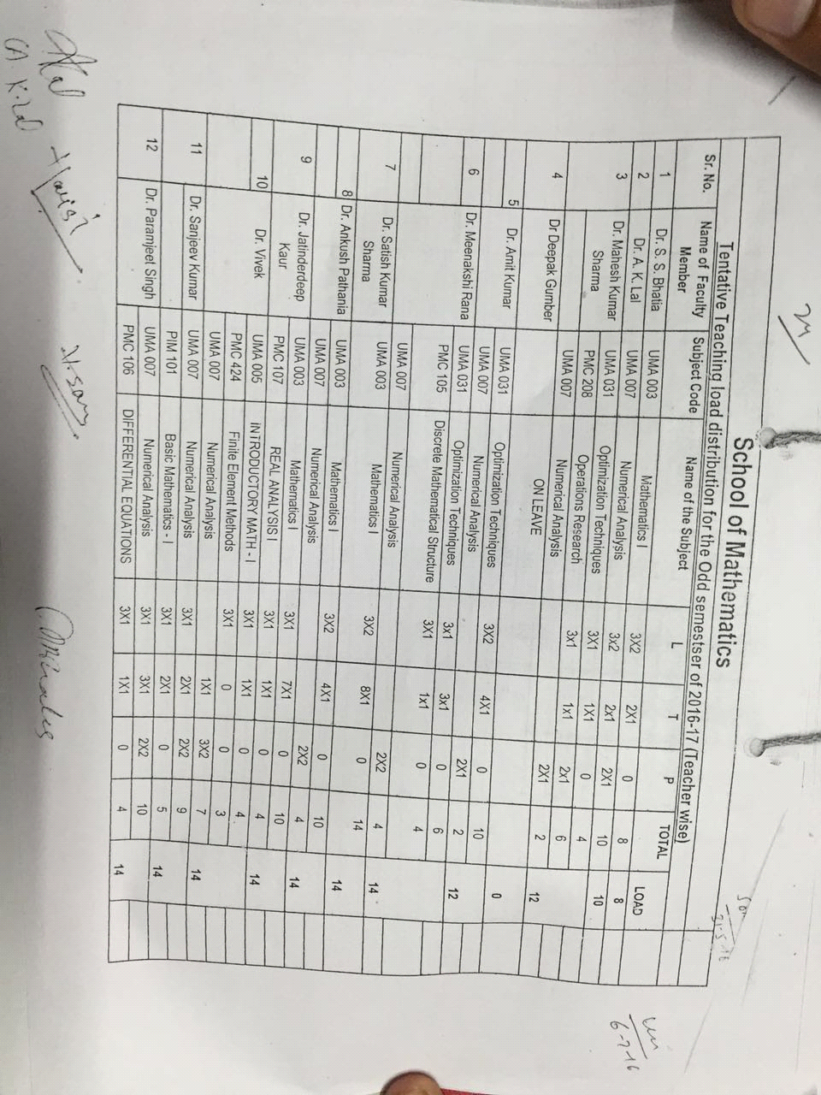

On the basis of sitting capacity university has two types of rooms :

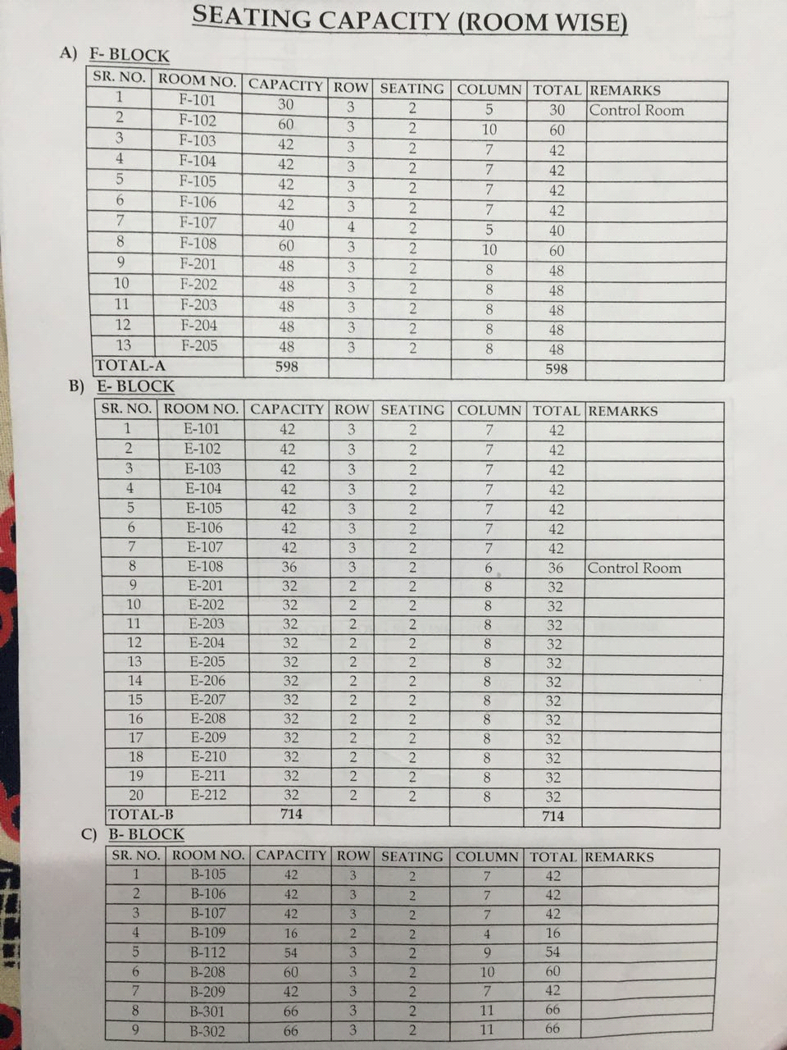

At last ,the time-table is made giving preferences to following points:

* The target of work hours for teachers should be completed precisely as decided for a week.

* The time slot for a group must not clash for a tutorial , lecture or a lab. For eg. A group xyz must not have a lecture @ 9-10 AM and having a tutorial class for same time slot.
* Lecture/Tutorial/Lab of a subject for a particular group is taken by a single teacher for entire semester until there is any case of emergency. For eg. If a teacher ‘A’ is taking lecture of group xyz on Monday , than he must take the lectures of that group on other lecture days also.
* There must be a time slot for students and teachers in which they can have their lunch .This time slot comprises of timings 12:00PM to 1:00PM or 1:00PM to 2:00PM or both.
* Priority must be given that there must be minimum walking for the students in between two lectures. For eg. It should be kept in mind to avoid the case in which a group has first lecture in F-block second lecture in TAN and third lecture in B-block .
* Lab/Tutorial room/Lecture room should not be given to two different groups at the same time means a room or lab should be available for a particular group for a slot.
* A teacher must not be having two lectures simultaneously.
* Timetable should be set such that the backlog or detained students can sync with other time tables too.

After dealing with all these preferences a final time table is made which goes to DOAA office for approval.

This time table is modified in various ways according to its need to various departments.

For the data about rooms we went to DOAA office. We met department heads and various departments’ time-table coordinators to get the codes of teachers along with their teaching load.

**STUDENT-WISE TIME-TABLE**

|  |  |  |  |  |  |  |  |  |  |
| --- | --- | --- | --- | --- | --- | --- | --- | --- | --- |
| **DAY** | **HOURS** | **COE 1** | | **COE 2** | | **COE 3** | | **COE 4** | |
|  | **1** |  | |  | |  | |  | |
| **M** |  |  |  |  |  |  |  |  |  |
|  | **2** | UES012 L | | | | | | | |
| **O** |  | F103 |  | | | | | | BCM |
|  | **3** | UMA007 L | | | | | | | |
| **N** |  | F103 |  | | | | | | PJS |
|  | **4** | UCS405 L | | | | | | | |
| **D** |  | F103 |  | | | | | | AKU |
|  | **5** |  | |  | |  | |  | |
| **A** |  |  |  |  |  |  |  |  |  |
|  | **6** | UTA010 | | UTA010 | | UCS304 P | | UCS304 P | |
| **Y** |  | T | | T | | BEMLDA | | CAG | |
|  | **7** | B304 | | B304 | | LAB | | UCE501 T | |
|  |  | VJ/ASL | | DK/GPS | | PBH | | F201 |  |
|  | **8** |  | |  | |  | |  | |
|  |  |  |  |  |  |  |  |  |  |
|  | **9** |  | |  | |  | |  | |
|  |  |  |  |  |  |  |  |  |  |

**TEACHER-WISE TIME-TABLE**

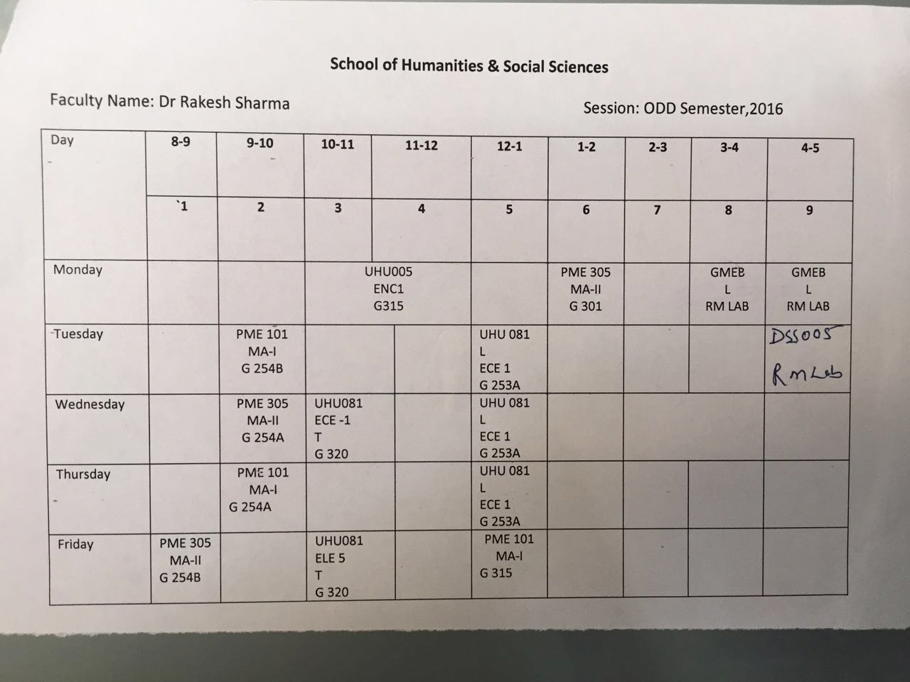

**LAB-WISE TIME-TABLE** 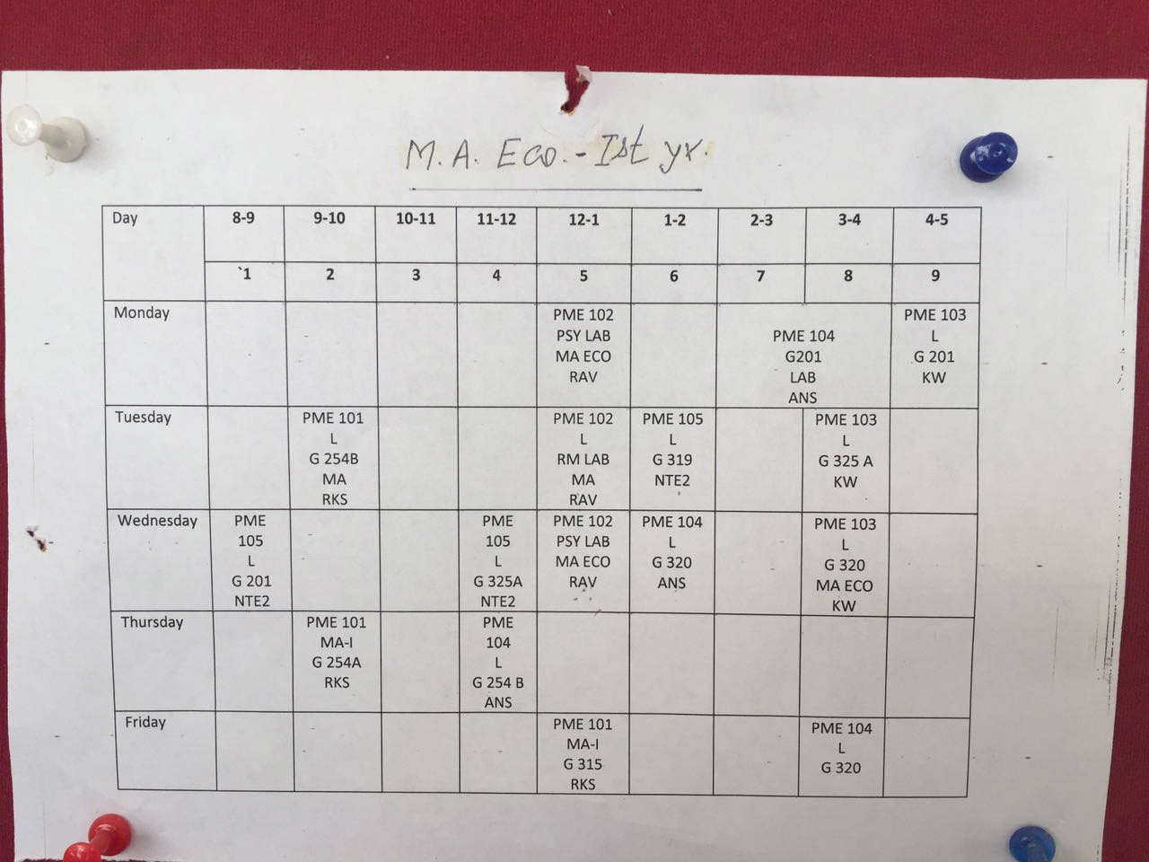

**4.2 ANALYSIS OF CONSTRAINTS**

On properly analyzing the procedure of the time table we had a rough idea about necessary tables and columns with the precise use of datatypes. We also got the idea about the constraints to fulfill the preferences and requirements of time table such as a teacher should be UNIQUE for a group for whole semester.

**5. REFERENCES**

5.1 [www.thapar.edu](http://www.thapar.edu/)

5.2 DOAA office

5.3 Various department offices and schools in the university.